

###### Savitribai Phule Pune University A

###### PROJECT REPORT ON

**“CANOPY DETECTION AND PESTICIDES SPRAYING USING AGRICULTURAL DRONES**”

###### Submitted in partial fulfillment of the requirement for the award of the degree of BACHELOR OF ENGINEERING

###### IN

###### ELECTRONICS & TELECOMMUNICATION ENGINEERING

###### By Sudhir Pawar

###### Yash Shinde Hrishikesh More

###### Under the guidance of Dr. Mrs. G. M. Phade



**DEPARTMENT OF ELECTRONICS & TELECOMMUNICATION ENGINEERING**

###### SANDIP FOUNDATION'S

###### SANDIP INSTITUTE OF TECHNOLOGY& RESEARCH CENTRE

###### Mahiravani, Trimbak Road, Nashik-422213 2020- 2021



###### SANDIP FOUNDATION'S

###### SANDIP INSTITUTE OF TECHNOLOGY& RESEARCH CENTRE

###### Mahiravani, Trimbak Road, Nashik-422213, Maharashtra.

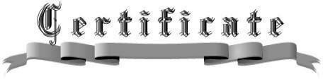

This is to certify that, this Project report entitled- “**CANOPY DETECTION AND PESTICIDES SPRAYING USING AGRICULTURAL DRONES.”**

Submitted by Mr. Sudhir Pawar, Mr. Yash Shinde and Mr. Hrishikesh More for partial fulfillment of the requirement for the award of the **Bachelor of Engineering** in **ELECTRONICS & TELECOMMUNICATION ENGINEERING** as laid down by the

**SAVITRIBAI PHULE PUNE UNIVERSITY**, Pune. This is a record of their own work carried out by them under my supervision and guidance during the year 2020-2021.

Place: -SITRC, NASHIK

Date: - Exam No.:

##### Dr. Mrs. G. M. Phade

#### Guide

##### Dr. Mrs. G. M. Phade

#### Head

DEPARTMENT OF ELECTRONICS & TELECOMMUNICATION

DEPARTMENT OF ELECTRONICS & TELECOMMUNICATION

### Examiner Dr. S. T. Gandhe

**Prof.**

##### PRINCIPAL (SITRC)

**ACKNOWLEDGEMENT**

The work procedure in this report would not have been completed without the encouragement and support of many people who gave their precious time and encouragement throughout this period. We would like to sincerely thank our project guide **Dr. Mrs. G. M. Phade** for her guidance and for the patience she showed us during the process of preparation of the project from the initial conception of final design and implementation.Lab and library in charge for kindly granting us access to the lab. We would also like to thank the teaching and non-teaching staff who helped us from time to time with their own experience and also, we would like to express our gratitude to the core of our heart, principal **Dr. S. T. Gandhe** Sir for being supportive and always encouraging.

Sudhir Pawar

Yash Shinde

Hrishikesh More

**ABSTRACT**

There are too many technologies involved in today’s Agriculture, out of which spraying pesticides using drones is one of the emerging technologies. Manual pesticide spraying causes many harmful side effects to the personnel involved in the spraying process. The Exposure effects can range from mild skin irritation to birth defects, tumors, genetic changes, blood and nerve disorders, endocrine disruption, coma or death. The WHO (World Health Organization) estimated as one million cases of ill affected, when spraying the pesticides in the crop field manually. This paved the way to design a drone mounted with spraying mechanism having 12 V pump, 5 Litre storage capacity tank,4 nozzles to atomize in fine spray , an hexacopter configuration frame ,suitable landing frame, 6 Brushless Direct Current (BLDC) motors with suitable propellers to produce required thrust about 38.2 KG(at 100% RPM) and suitable LithiumPolymer (LI-PO) battery of current capacity 22000 mAh and 22.2 V to meet necessary current and voltage requirements. A First-Person View (FPV) camera and transmitter can also be fixed in the drone for monitoring the spraying process and also for checking pest attacks on plants. This pesticide spraying drone reduces the time, number of labor and cost of pesticide application. This type of drone can also be used to spray disinfectant liquids over buildings, water bodies and in highly populated areas by changing the flow discharge of the pump.

**Table Content**

Acknowledgments Abstract

List of Figure i

Chapter 1 1

Introduction 1

Chapter 2 2

Literature Survey 2

Chapter 3 5

Problem Statement and Objective 5

* 1. Statement of the Problem 5
  2. Objective 5

Chapter 4 6

Proposed system 6

* 1. Proposed block diagram 6
  2. Software requirement 8

Chapter 5 9

Software Based Proposed System and Its Output 9

Chapter 6 15

Conclusion 15

|  |  |  |
| --- | --- | --- |
| 6.1 | Conclusion | 15 |
| 6.2 | Future scope | 15 |
| 6.3 | Advantages | 15 |
|  |  |  |
| Chapter 7 | | 16 |

References 16

**List of figure**

###### Name of the Figure Page No.

|  |  |  |
| --- | --- | --- |
| Figure 4.1 | Proposed block diagram | 6 |
| Figure 5.1 | Raspberry pi | 9 |
| Figure 5.2 | Sparying Mechanism | 10 |
| Figure 5.3 | Output | 11 |

# Chapter 1

Introduction

The Indian Agricultural sector is the most important sector as it amounts to a staggering 18% of India’s Gross Domestic Product (GDP) and also provides employment to 50% of the national human workforce. Our country is dependent on agriculture so much, has yet to tap into the real potential of agriculture, because of improper methods of monitoring crops and the irrigation patterns and the pesticides required to be applied. In India, there are over 35 drone start-ups that are working to raise the technological standards and reduce the prices of agricultural drones. This project aims to develop Unmanned Aerial Vehicle (UAV) for overcoming this problem and also spay large amounts of pesticides within smaller interval of time using Hexaocopter. To achieve this, an Unmanned Aerial vehicle (Drone) is designed by using spare parts like BLDC (Brush Less DC) motors, ESC’s (Electronic Speed Controllers), Flight Controller, Propellers, drone base, power distribution board, RF Transmitter, receiver etc. for controlling purpose are integrated to it. In addition to that several applications like spraying, crop and weather monitoring are also added. For these, the required components are water level sensor, DH11, LDR, water sprinkler, connecting wires, motor driver and finally, an advanced Raspberry Pi for controlling all the components. It has inbuilt Wi-Fi, Bluetooth, serial and parallel bus connectors, audio, video jack, hdmi cable, usb ports, ether net jack and 40 GPIO (General Purpose Input Output) pins. Due to all these special features in-built in Raspberry pi, it is chosen over the other controllers in this project. Python language is used for programming the Raspberry pi. Raspberry pi is treated as the minicomputer i.e. a system on hand. Rasbian is the OS available in the internet for free of cost. One can download that and install it into the memory card and use it as a computer. For particular components to interface, special drivers have to be installed.

# Chapter 2

Literature Survey

* **Huang et al. (2015)** made a low volume sprayer which is integrated into unmanned helicopters. The helicopter has a main rotor diameter of 3 m and a maximum payload of 22.7 kg. It used to require at least one gallon of gas for every 45 minutes. This study paved the way in developing UAV aerial application systems for crop production with higher target rate and larger VMD droplet size.
* Chennai based **ZUPPA** provides farm, irrigation, and crop monitoring through use of drones and aerial mapping.
* **Kurkute et al. (2018)** worked on quadcopter UAV and its spraying mechanism using simple cost-effective equipment. The universal sprayer system is used to spray for both liquid and solid content. In their research, they have also compared different controllers needed for agricultural purposes and concluded that quadcopter system with Atmega644PA is the most suitable due to its efficient implementation.
* **Rahul Desale et al. (2019)** described an architecture based on UAV that could be employed for agricultural applications. Their UAV was designed not only for spraying but also for monitoring agricultural fields with the use of cameras and GPS. Their design was optimized for cost and weight. They used a microcontroller kk 2.1.5 which has inbuilt firmware. Prof. B. Balaji et al. (2018) [6] developed an hexacopter UAV with the purpose of spraying pesticides as well as crop and environment monitoring using Raspberry Pi that run on python language. Their UAV also contains multiple sensors like DH11, LDR, Water Level Monitoring sensors. From this experiment, they finally concluded that with proper implementation of UAVs in the agricultural field almost 20%- 90% savings in terms of water, chemical maltreatments and labor can be expected

# Chapter 3

Problem Statement and Objective

* 1. Statement of the problem

To design and develop cost effective agriculture drone for sapling detection and pesticides spraying purpose with the help of High Speed STM32 processor along with BLDC motors, Li-Po batteries, ESCs pesticides tank, pump and propellers and in the end to train the farmers to operate the drones.

* 1. Objective

1. Drone capable of carrying payload of 5 kg.

2. Drone with ability to detect a sapling autonomously.

3. Reducing the cost required for the drone compared to present solutions.

# Chapter 4

Proposed System Development

* 1. Proposed Block Diagram

Figure 4.1: Proposed block diagram

* 1. Software Requirement
     + Raspberry Pi OS
     + Mission Planner Software
     + Python OpenCV
  2. Hardware Requirement
* Drone
* Raspberry Pi
* Pump
* Water Sprinkler
* Motor Driver IC
* Water Float Sensor

# Chapter 5

Software Based Proposed System

**RASPBERRY PI** :-

It look like a credit card but it perform as a mini computer .it used for many things that desktop PC does like video word processing,

spread sheets, home automation server,

parent detectors to weather stations,

tweeting houses of birds with IR cameras etc.

After installing the Raspbian OS we can get the Raspberry pi desktop as shown in the fig

which is similar to our normal computer desktop.

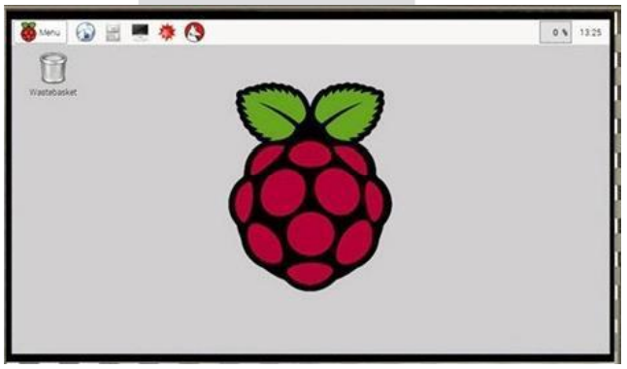

Figure 5.1: Raspberry Pi

**Spraying Mechanism: -**

There are a lot of plant protection products exist today. Main pesticides that used in precision agriculture are:

1) Insecticides

2) Fungicides

3) Herbicides

Crops spraying Drones suited ideally for

such task, because most fields need ultra-

low application volumes of pesticides per hectare, only on some specific zones of a field and only at some specific time.

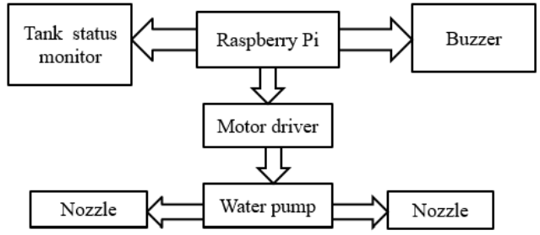

Figure 5.2: Spraying Mechanism

Green Field Detected: (Output)

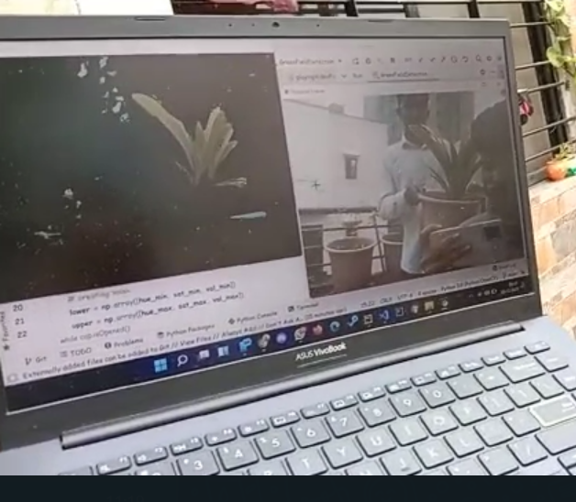

**CODE:**

import cv2  
import numpy as np  
  
hue_min = 25  
sat_min = 52  
val_min = 72  
  
hue_max = 102  
sat_max = 255  
val_max = 255  
  
cap = cv2.VideoCapture(0) # video capturing  
  
while cap.isOpened():  
 ret, frame = cap.read() # original frame  
  
 vidGray = cv2.cvtColor(frame,cv2.COLOR_BGR2HSV) #hsv frame  
  
 # creating mask  
 lower = np.array([hue_min, sat_min, val_min])  
 upper = np.array([hue_max, sat_max, val_max])  
  
 mask = cv2.inRange(vidGray, lower, upper) #applying mask to the hsv frame  
  
 # bitwise anding to each pixel to get the object  
 Green = cv2.bitwise_and(frame, frame, mask=mask)  
  
 cv2.imshow("Green Field Detection", Green)  
 cv2.imshow("Original Frame", frame) #original video  
  
 if cv2.waitKey(1) == ord('q'):  
 break  
cap.release()  
cv2.destroyAllWindows()

Figure 5.3: OUTPUT AND CODE

# Chapter 6

## Conclusion

* This method of spraying pesticides on Agricultural fields reduces the number of labors, time, cost and the risk involved to the personnel involved in spraying the liquids. This drone can also be used in spraying disinfectant liquids over buildings, water bodies and highly populated areas.
* Drone is responsible for both spraying chemicals and monitoring of agricultural fields, environment.
* It helps in improves coverage, boosts chemical effectiveness and makes spraying job easier and faster.
  1. Future Scope
* The maximum quantity of fertilizer that the drone carries can be increased.
* Battery life can be increased.
* With image processing techniques, the drone can be involved in surveillance to determine the pest attack on the plants, condition of ripening fruit.
  1. Advantages:
* High Productivity
* Low Fuel Consumption
* Low Noise Pollution
* No chemical contamination risks for operator
* Crop dusting costs are much lower
* Ultra-low volumes spraying methods, avoids waste of water and ground waters contamination
* Multifunctional Frame

**Chapter 7** References:

* C. Zhang, J. M. Kovacs, ”The application of small unmanned aerial systems for precision agriculture: a review”, Precision Agriculture, Springer, 2012.
* MIT Technology Review, ”Agricultural Drones. Relatively cheap drones with advanced sensors and imaging capabilities are giving farmers new ways to increase yields and reduce crop damage”, http://www.technologyreview.com/featuredstory/526491/agricultural-drones/, 2015.
* I. Colomina, P. Molina, ”Unmanned aerial systems for photogrammetry and remote sensing: a review”, ISPRS Journal of Photogrammetry and Remote Sensing, June 2014.
* L. Hassan-Esfahani, A. Torres-Rua, A. M. Ticlavilca, A. Jensen, M. McKee, “Topsoil Moisture Estimation for Precision Ag riculture Using Unmanned Aerial Vehicle Multispectral Imagery”, 2014 IEEE International Geoscience and Remote Sensing Symposium, 2014.